Kerry Wong Sze Kay 272135

**• What will be the output when running the above code?**

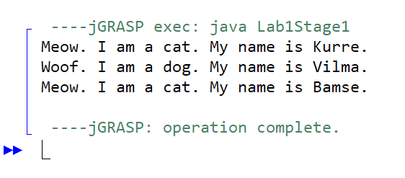  
**• What is meant by polymorphism ?**

Polymorphism means "many forms", and it occurs when we have many classes that are related to each other by inheritance. Inheritance lets us inherit attributes and methods from another class. Polymorphism uses those methods to perform different tasks. This allows us to perform a single action in different ways. The most common use of polymorphism in OOP occurs when a parent class reference is used to refer to a child class object.

• **How does polymorphism work in the above program?**

The superclass is Animal that has a method called introduceYourself(). The subclasses of Animals is Cats class and Dogs class. These 2 subclasses also have their own implementation of introduceYourself().

• **The method introduceYourself of Animal appears to be never called? Why not?**

The method introduceYourself of Animal appears to be never called because Cat and Dog class have override the method with their own implementation of the same method.

**• Comment out the method introduceYourself in Dog. What happens now when you run the program?**

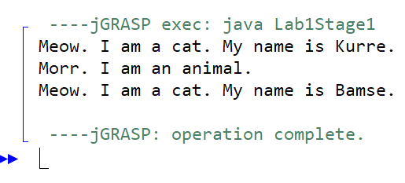

**• Where is the name stored for the instances of Cat and Dog? (In what / which classes did you put the instance variable that refers to the name of the animal? Both Cat and Dog, or just in Animal?)**

In class Cat and class Dog, I put the instance variable that refers to the name of the animal.

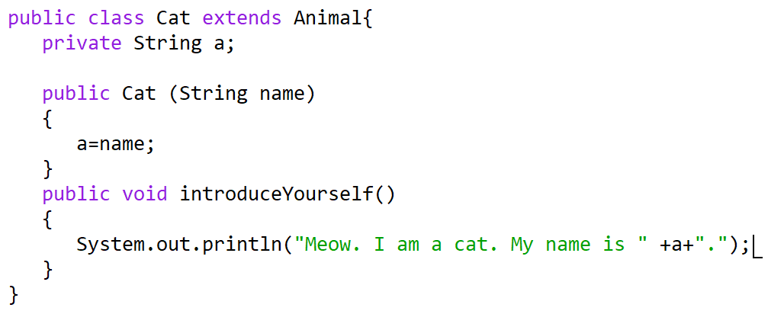

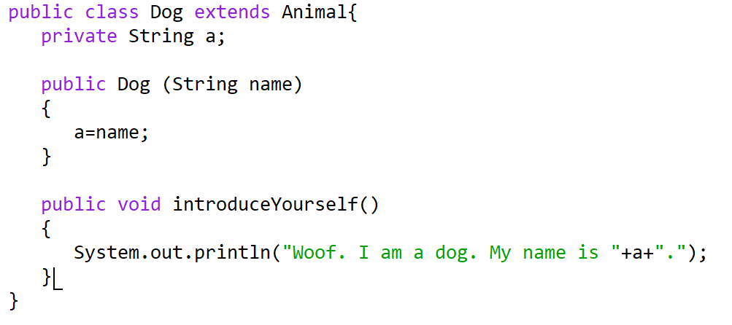

**• How does the code in the test program work?**

I have a superclass which is Animal class that has a method introduceYourself().

Then there are two subclasses of Animal class which is Cat and Dog that extends Animal class.

At the class Lab1Stage1 have main and contain array and create a Animal object with array.

The array Animal have create object for Cat and Dog to call the method in their class.

**• How does an array work?**

An array is a collection of items. Each slot in the array can hold an object or a primitive value. Arrays in Java, as in other languages, are a way to store collections of items into a single unit. The array has some number of slots, each of which holds an individual item. You can add and delete items to those slots as needed. Unlike in other languages, however, arrays in Java are actual objects that can be passed around and treated just like other objects.

**• In the above programs we have used a while loop to step through the array and to get information about the animals. But there is a more appropriate loop statement here. What is it?**

By using a for loop to reduce the length of the code and avoid using additional variables.

**for (int i = 0; i < allAnimals.length; i++) {**

**allAnimals[i].introduceYourself();**

**}**